LTAC Summer Reading
7th grade 2017-18 school year

Required Novel
I am Malala: The girl who stood up for education and was shot by the Taliban
by Malala Yousafzai

*There is a “Young Reader’s Edition” of this text. Please do not read the young reader’s edition. Please read the full edition.

Required Novel of Choice
Enrique’s Journey: Young Reader’s Adaptation by Sonia Nazario
*Please DO read the young reader’s edition

Brown Girl Dreaming by Jacqueline Woodson

*You will read I am Malala and then please choose one of the other two novels to read. Read them both if you are feeling ambitious :)

Welcome to LTAC! We are thrilled you will be joining us here at Lane Tech College Prep. Your time at Lane will be filled with intellectual challenges, discovery, and discussion. Your seventh grade year will launch you on an academic journey, during which you will study some of the greatest literary, scientific, philosophical and mathematical thinkers.

As we work to examine these voices, we will also begin to examine how you, as an independent thinker, shape your voice. As we work to form our own personal beliefs, we will be adopting and shaping personal wisdom.

Your summer reading project serves as the first stepping stone on your journey. The novels chosen for the summer reading project will help you begin to think about who you are and who you want to be. You will be reading I am Malala and either Enrique’s Journey or Brown Girl Dreaming.

The memoir you will be reading is about a young girl who felt so strongly about having the right to a personal academic journey, that she was willing to risk her life for education. Malala comes from a very different background, neighborhood, and culture than what we experience here in America. She risked her life every day for something you and I experience for free and as a basic human right, one we often begrudge and take for granted at that. Malala Yousafzai spoke out in support of girls’ rights to equal educational opportunities in her native country, Pakistan, during the conservative and extremist Taliban rule.

As you read her story, along with the novel of your choice, it will become clear just how important and powerful one voice can be in the face of extreme adversity--and how different those voices can sound. We will be using this literature throughout the entire school year: first, with in class activities and assessment, and later to connect thematically throughout the year.

The Assignment
The first step in your summer reading assignment is to simply read I am Malala and the novel of your choice.

As you read both pieces please do the following:
1.Define words you don’t know

2. Please complete the attached graphic organizers to the best of your ability.

You will bring the completed graphic organizers with you to school on
Monday September 11
Please do not stress about completing the graphic organizers and do them to the best of your ability. Know that the first few weeks of school we will touch base and discuss the graphic organizer and the content.
*You will be using the graphic organizers on some of the first writing exercises we will do in the fall

4. Use the graphic organizers to help you in your thoughts and conversations about the discussion questions below.

5. Enjoy your summer and your summer reading.

DISCUSSION QUESTIONS
As you read the memoir, I am Malala, please consider the answers to the discussion questions provided. You do not need to write down your responses in a formal way, unless you choose to do so. Our suggestion is that you discuss these answers with other friends entering LTAC or your family members.

- Talk about the role of Malala’s parents, especially her father Ziauddin. How does her father break the societal norms of what a father should be? If you were her parents, would you have encouraged her to learn to read and write, and to speak out?
- Why does the Taliban want to prevent girls from acquiring an education? How does the Taliban see the role of women in a society? How is this similar and different to America and the role of women and men in society?
- Malala says that her father “believed that lack of education was the root of all of Pakistan’s problems” (41). Does education cure all problems? How does it make life different/better? What doesn’t education do? How do you relate these ideas to your own education?
- Malala writes, “In Pakistan when women say they want independence, people think this means we don’t want to obey our fathers, brothers or husbands. But it does not mean that. It means we want to make decisions for ourselves” (219). What is the difference? In the US, we put great stock in the idea of independence – how is our understanding of independence similar or different?
- Talk about the international outrage after Malala’s shooting. Did the outrage make a difference? Why? How does this compare or contrast to the international or national outrage over the injustices seen in your other novel?
- Do you agree with Malala’s assertion that “the pen and the words that come from it can be much more powerful than machine guns, tanks or helicopters” (157)? If yes, what examples or situations can you think of in your own life or in American culture, where this is true? If no, why and/or when is military force a better option than subversive activism?

As you read the novel, Brown Girl Dreaming, please consider the answers to the discussion questions provided. You do not need to write down your responses in a formal way, unless you choose to do so. Our suggestion is that you discuss these answers with other friends entering LTAC or your family members.

- The novel is not written in a traditional way. Each chapter is written in verse. How does this affect your understanding of the setting, the conflicts, and the character’s relationships?
- What or who are the strongest influences in the development of Woodson’s identity? How do you know?
- How does Jacqueline’s life differ in the North than in the South?
- Woodson shares her childhood experiences in the backdrop of the Civil Rights movement. How do you see the societal and political turmoil played out in her life?

As you read the novel, Enrique’s Journey, please consider the answers to the discussion questions provided. You do not need to write down your responses in a formal way, unless you choose to do so. Our suggestion is that you discuss these answers with other friends entering LTAC or your family members.

- What are Enrique’s, and the other traveler’s, motivations to come to the United States? Do you agree with those motivations? Do you think those motivations are just and sound?
- What are some of the barriers or struggles Enrique faces once he reaches America? Does he expect them? Could he have better prepared for the reality of life in America? If so, how?
- We will be reading excerpts from Upton Sinclair’s The Jungle this year. He claims that with that novel, “he aimed for America’s heart and hit its stomach instead” because his novel was received with such strong alarm. What do you think Nazario wishes to inspire in her readers?
- What is your family’s story of immigration? Were your family’s motivations for coming to America similar to Enrique’s? How so or how were they different?

One way to make these texts even more valuable is for other members of the family to read the texts along with the LTAC student. This way, you can actually have conversations about the discussion questions provided and open a dialogue about the importance of education, freedom, diverse voices, and speaking up for what is right

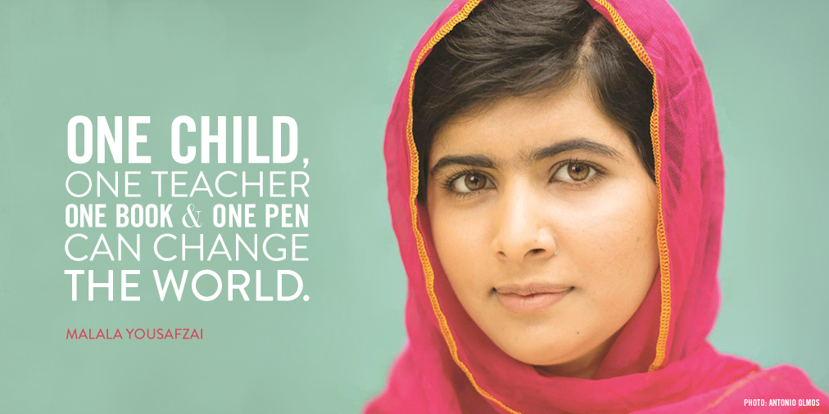
I am Malala by Malala Yousafzai → Complete graphic organizer and bring to class Monday September 11

Make a list of all the leadership qualities Malala possesses:
Example: Determined

Choose 3 main leadership qualities Malala possesses and explore HOW she demonstrates these leadership qualities as seen in her book.

Leadership Quality | Page Number from book | Explain HOW this leadership quality is shown and what is the result of the leadership quality?
Determined | “The Tailban could take our pens and books, but they couldn’t stop our minds from thinking” (146). | Malala is determined to prove herself to the Taliban, her country, and all those who doubt her drive for education. She does not let the fact that she does not have a school, a textbook, or a pencil deter her from using her knowledge, from thinking, from using her brain. Malala is not easily deterred from her dream or goal to bring educational rights to girls all over the world.
Enrique’s Journey
Brown Girl Dreaming
→ Complete the graphic organizer for the novel you chose to read and bring it to class September 11

A person’s identity is very complex and is influenced by a variety of factors. Some of the things that influence and shape who we are include: our family, our religion, our gender, the political environment, and our hopes and dreams for the future.

Please consider how both Enrique and Jackie form their identities based on these factors. What characteristics do they possess because of their unique circumstances and how and why do you know. List a characteristic or trait that your character possesses because of the various factors influencing their identity. See the example below:

IDENTITY
Character:

FAMILY
Political Environment
Hopes & Dreams
Gender or Race

CHARACTER: Enrique OR Jackie (circle one)

Family | Political Environment | Hopes & Dreams | Gender or Race

Example: JACKIE

Independent: Jackie is raised by a single mother. She has to learn to take care of herself and her siblings. They traverse between the South and the North (sometimes with their mother and sometimes without). She learns from her grandparents and her aunt, but ultimately must struggle to find herself on her own as her experiences are unique. | Aware but naive: As Jackie goes back and forth between life in the north and life in the south, she gets an interesting glimpse of the limited freedoms in both regions of the country during a racially charged time period. Her uncle is politically involved and attempts to teach her about the Revolution. Her age limits her ability to understand some of the things she is learning and experiencing (like hearing Angela Davis etc) | Creative: Jackie wants to be a writer. Her family laughs and thinks it is a nice hobby, but she feels a need to write. She does not excel in school the way her sister does, but she is a very creative thinker and good writer. | Confident: Jackie uses her writing to gain confidence. She works through her feelings and inadequacies through words. In the end, it is her words that give her a voice.

